D-311 Unit 9: Daily Duties

Summary:
This unit will focus on the typical daily duties of the IADP.

Objectives:
- Describe the daily dispatch office functions.
- Describe the dispatching steps to implement a routine incident dispatch.
- Describe the responsibilities of the IADP as they relate to implementing established emergency (non-suppression) dispatch plans.
- Identify situations that increase dispatch complexity.
- Describe how these events/incidents affect you as an IADP and what local guides may assist you.

Unit at a Glance:
Topics | Method | Duration
Unit Overview | Presentation | 10 Minutes
Daily Duties/Routines of an IADP | Presentation  and Group Activity | 15 Minutes
Information Exchange | Presentation  and Group Activity | 5 Minutes
Steps to Implement a Routine Incident Dispatch | Presentation  and Group Activity | 30 Minutes
Steps to Implement an Emergency Plans | Presentation  and Group Activity | 10 Minutes
Situations that Increase Dispatch Complexity | Presentation  and Group Activity | 15 Minutes
Knowledge Check | Group Activity | 5 Minutes
Total Unit Duration |  | Total 90 minutes

Preparation:
This section appears at the beginning of the course and unit. It indicates all steps you need to take to prepare for delivery.

Course Materials:
Exercise 1 Handout – 1 per student

Classroom:
- Ability to display images and video on large screen.
- White board or easel access for group breakouts.

Key

Headings with icons:
Review

Handout

Reference Standard

Group Discussion

Play Video

Activity

Slide 1
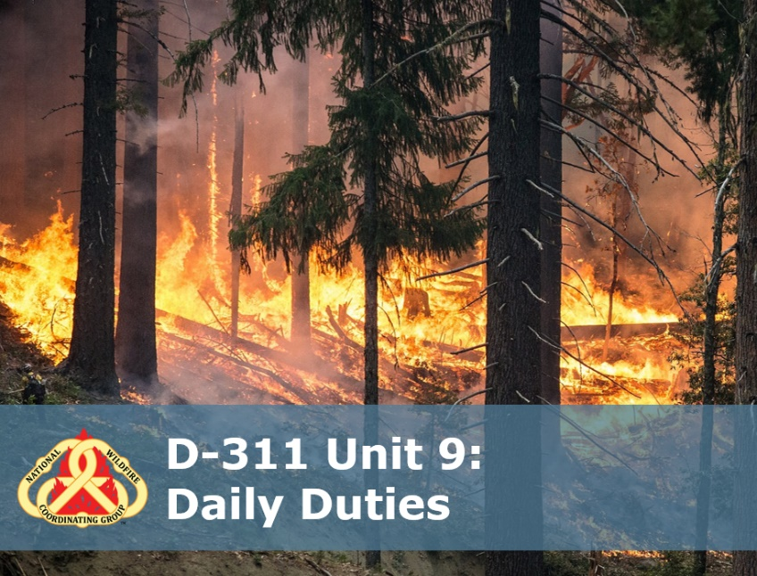
Situational Awareness
DO:
Explain to the students on how this unit is organized for learning. As a single resource IADP unit, the following topics list the topics in order:
- Present & group discussion the basic daily duties of the IADP
- Present & group discussion steps for a routine wildland fire incident.
- Present information on how to implement emergency (non-suppression) incident plans.
- Present and discuss situations that increase dispatch complexity and how the IADP can handle those situations.

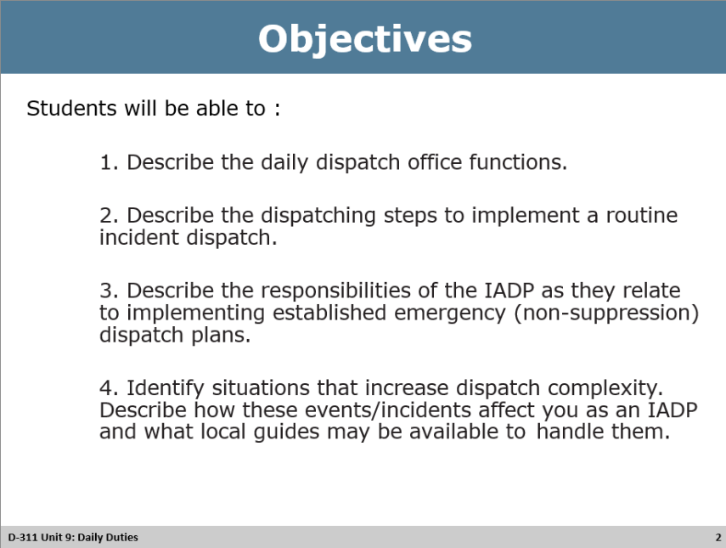
Review Unit Objectives
DO: Refer the participants to the objectives as listed in the PowerPoint slide. Allow time for the participants to review.
Handout
Materials: D-311 Unit 9 Daily Duties powerpoint
Purpose: Participants use the handout as an organizer during the instructor lecture.
Directions:
- Distribute the handout to participants of the class while explaining the purpose of the handout.

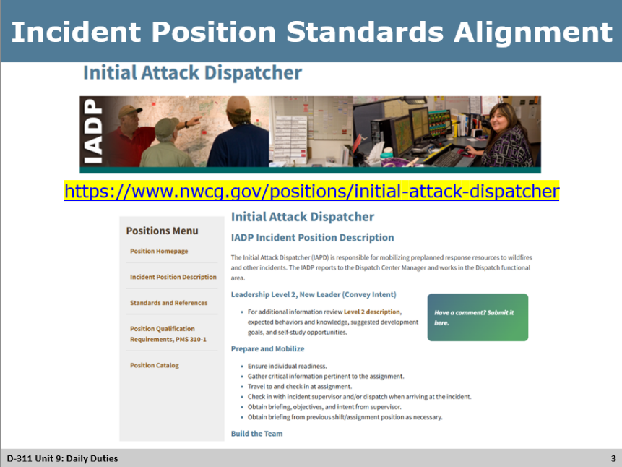
Review Incident Position Standards Alignment

Incident Position Standards
Review Incident Position Standards Alignment
DO: Refer to the Incident Position Standards Alignment slide and allow participants a moment to review their copy of the Incident Position Standards document, specifically the Table of Contents, as it relates to the Unit’s topic.
ASK: What responsibilities statements might align with preparing for an assignment in an initial attack dispatch center?
Answer: Listen for responses like
  - Review checklists and center standard operating procedures
  - Get briefing upon arrival
  - Get daily/shift briefing if applicable
  - Ensuring access to dispatch programs – FireNet, IROC, WildCAD-E
  - Review local emergency procedures
  - Others?

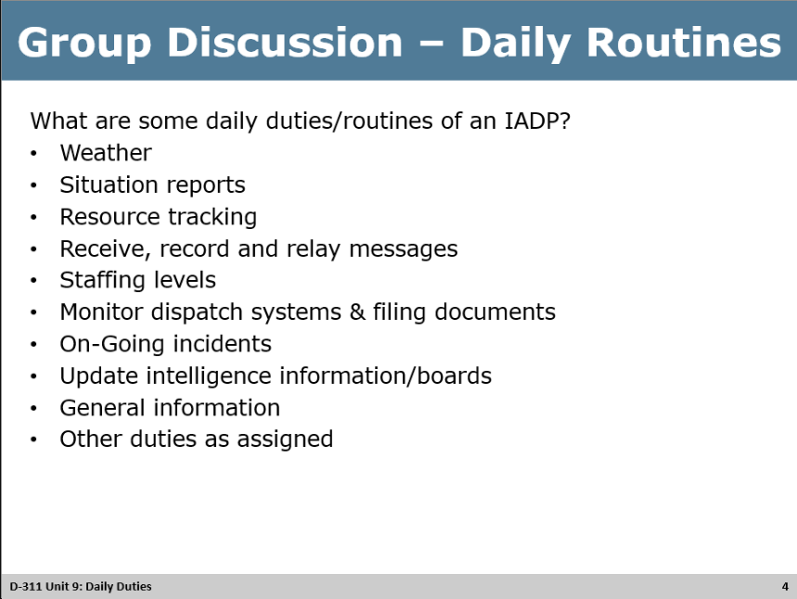
Group Discussion
DO: Refer participants to the corresponding PowerPoint slide listing question/topics/discussion points
Instructor: Discuss each section and possible answers as a group in class. Emphasize importance of each task and ramifications if they aren’t done correctly or on time.
ASK: What are some of the daily duties/routines of an Initial Attack Dispatcher?
Answers: Weather
  - Process and disseminate fire/weather forecasts,
  - Red Flag and weather alerts,
  - Spot forecasts.
- Situation Reports
  - Review national, regional and local situation reports
  - Disseminate as needed
  - Update daily reports
- Resource Tracking
  - Spreadsheets, websites, applications
  - CAD System
  - White Boards/Maps
  - Fire & administrative resources
- Receive, record and relay messages
- Staffing levels – discuss what they are and why are they important
  - Determine policy and set levels
  - Who has authority to change?
  - What are reasons it could change? Multiple incidents, weather, limited resources, lower priority protection zones
- Monitor dispatch systems & filing documents
  - IROC
  - Central email/FireNet
  - SharePoint & Center folders
  - TEAMS channels
- On-going incidents
  - Status
  - Resources – committed & needed
  - Frequencies
  - Updates/Intel
  - TFRs
- Update intelligence information/boards
  - Weather
  - Aviation
  - On-going incidents
  - Fire Resources
- General information
  - Fire restrictions
  - General Messages
  - Public/Agency events
  - Private/military blasting
  - Open burning
  - Temporary phone numbers
- Other duties as assigned
  - On-going projects
  - Manual and guide updates
  - AD Pay reimbursements
  - Everything else

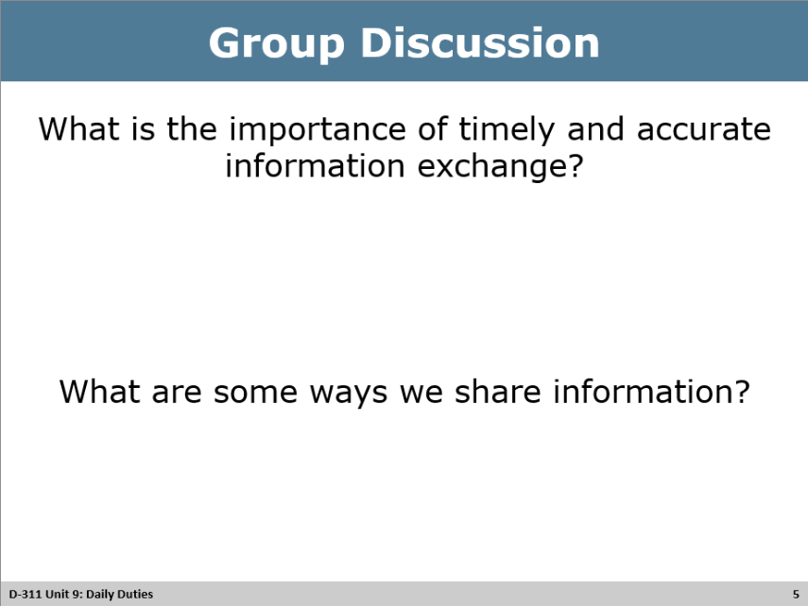
Group Discussion
DO: Refer participants to the corresponding PowerPoint slide listing question/topics/discussion points
ASK: What is the importance of timely and accurate information exchange?
Answer:
- Critical information gets to the right people at the right time
- To build trust
- Resources get dispatched correctly and on time
- Others?

ASK: What are some ways we share information?
Answer:
- Radio
- Phone / texting
- In-person
- email
- Websites
- TEAMS / instant messaging
- Spot devices
- Others?
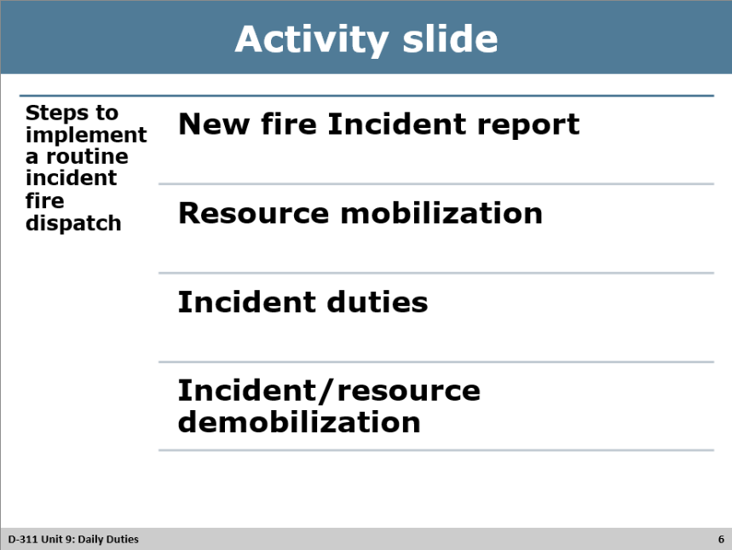
Activity
<Steps involved to implement a routine incident fire dispatch>
Materials: Whiteboard/flipchart & markers or pad & paper
Length: 30 minutes (5 min briefing, 15 minute activity, 10 min debriefing)
Purpose: The purpose of this activity is to provide students with the opportunity to continue to develop as a team while they recall information presented in previous units to collaborate as a table group to list the steps to implement a routine wildland fire incident dispatch.
Directions:
- Assign one of the following topics to each table to list the steps. If there are more tables than topics, you can assign the same topics to other tables.
  - New Fire Incident Report
  - Resource Mobilization
  - Incident Duties
  - Incident/Resource Demobilization
- Review the following directions for this activity. Tell students to break into groups and list steps for their topic.
  - Tell them to select a recorder, a devil’s advocate, and a spokesperson for this group.
  - Tell them they have 15 minutes to complete the activity.
  - Tell them a will be a coach with them if they have any questions.
  - Send them to their breakout areas.
- At the end of 15 minutes, have each group spokesperson share their team findings. If assignments are doubled, have one group report out and ask the second group if they found anything different or have anything to add.
Coach Directions:
- Review the specific directions in the Instructor Guide for this team’s assignment.
  - Answer questions and provide prompts as necessary.
  - At the end of 15 minutes, have students return to the main classroom and complete the Skill Assessment for each student.
- Activity Debrief Questions: Answers are listed under each subheading, review any that students might not have listed during their report out and discuss importance.
  - New Fire Incident Report
    - Receive report – get the information: who, what, where, when, how
    - Acquire Reporting Party (RP) name and call back number
    - Document incident report information immediately. Why is this critical?
    - Plot reported incident location.
      - Determines agency jurisdiction (suppression protection)
      - Determines land status (private or public lands, wilderness, others)
      - Determine best access
    - Determine appropriate dispatch actions via CAD/Incident Run cards/local agency direction.

  - Resource Mobilization
    - Advise resources being dispatched & confirm departure and ETE/ETA
    - Advise responding units on incident frequencies
      - Command
      - Tactical
      - Air to ground
      - Air to air (as needed)
    - Identify location/access
    - Describe initial report to responding resources (repeating the who, what, where, when, how)
      - Incident type (Smoke check, WF, Vehicle fire, Haz mat, etc.)
      - Reporting Party w/name & Callback number
      - Estimated size
      - Reported fire behavior
      - Fuels
      - Color of smoke
      - Known weather conditions (where can you find this? CAD, NWS page, websites)
    - Identify known ground and air hazards
    - Advise on cooperating agency resources responding (if any)
    - Implement “bump & cover” resources. Some centers may not use.
    - Evaluate incident constraints
      - Sunset times
      - Response level
      - Suppression zone/values at risk
      - Long hike in times/remote location
      - Identify threatened and endangered species
      - Identify management concerns – wilderness, sensitive area tactics need to be used.
  - Incident Duties
    - Additional on-going tasks related to new incident
      - Confirm agency Duty Officers are notified
      - Assign Incident number and appropriate fire codes
      - Advise Geographic Coordination Center of committed National resources
      - Accurately and timely documentation of information
      - Accurate fire resource status
      - Coordinate with logistics section (if applicable) for additional needs
      - Notify public utilities of threats when needed
      - Notify local law enforcement as needed
      - Identify Public Information Officer or someone to handle media calls
    - Arrival of first units
      - Determine Incident Commander and communicate to responding units
        - Instructor: discuss the impacts of this – 30-mile, South Canyon, etc.
      - Request size up information
      - Establish incident ground contact for aviation resources
      - Determine Incident resource needs – adequate or additional needed? Cancel and return unneeded resources
      - Confirm frequencies
    - Provide for firefighter safety
      - Provide for good communication between IC and Dispatch on situational changes (weather, incoming resource status, etc.)
      - Notify management and responding resources of any changes of IC
      - Consider work-rest ratios
      - Consider additional needs – meals, resources, extended staffing, etc.
  - Incident/Resource Demobilization
    - Determine resource availability
    - Re-assign to other incidents as necessary
    - Return to Station
    - Accurately status resources

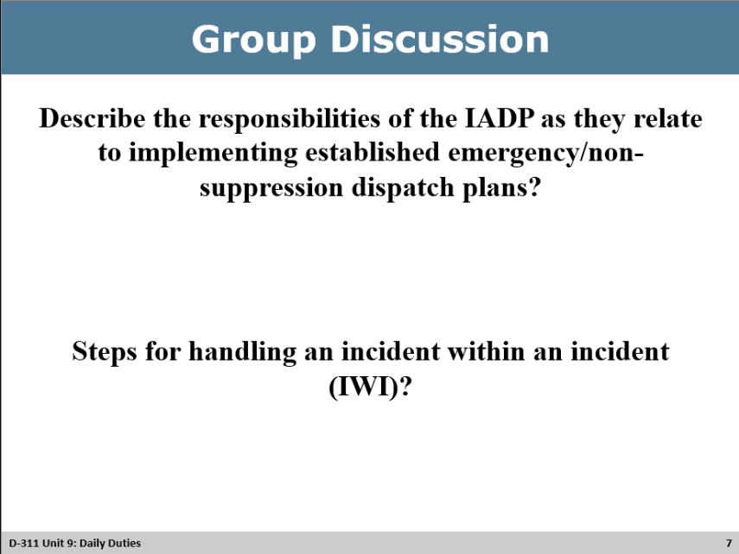
Group Discussion
DO: Refer participants to the corresponding PowerPoint slide listing question/topics/discussion points
Instructor: Explain how wildland fire dispatching is, for the most part primarily fire response. But because of increasing workloads and the interagency aspect of most centers, IADPs need to be able to efficiently dispatch resources to non-wildland fire incidents. For example, all risk, law enforcement, aviation and incidents within an incident (IWI)
ASK: Describe the responsibilities of the IADP as they relate to implementing established emergency/non-suppression dispatch plans?
Answers:
- Obtain a briefing on emergency plans
  - Different types of plans (Search and rescue, hurricane, hazmat)
  - Location of plans within dispatch center
  - Discuss office protocols
    - Roles and responsibilities
    - Notifications – Center Manager, Duty Officer, Agency Line Officer, etc.
    - Dispatcher authority

ASK: Steps for handling an incident within an incident (IWI)?
Instructor: Have students come up with answers and discuss others not listed on the sub lists.
Answers:
- Determine nature of incident & pull appropriate plan
- Start and incident report based on center policy
- Respond appropriate resources to mitigate incident
- Prioritize actions based on life, property and individuals’ safety
- Determine dispatcher’s responsibilities
  - Proper notifications
  - Document all dispatch actions
  - Close any loops
- Dedicate dispatcher to implement plan for the new incident
- Preserve incident related documentation and evidence
- Debrief as appropriate
  - One on one
  - Through written shift notes
  - Have After Action Review (AAR) to discover where/if response can be improved

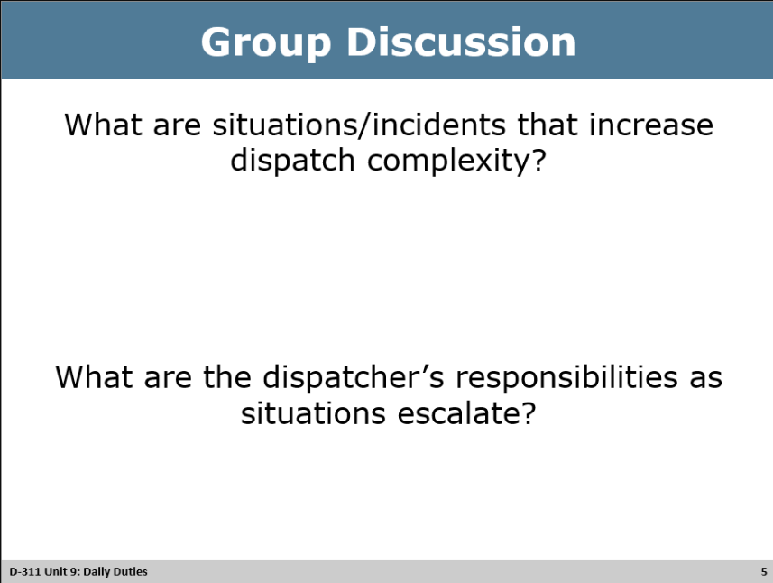
DO: Refer participants to the corresponding PowerPoint slide listing question/topics/discussion points
Instructor: Discuss situations that increase dispatch complexity. How do these events affect you as an IADP and what local guides may be available to handle them? Have students & cadre draw on past experiences and how they handled them. Describe how these events/incidents may affect you as an IADP.
ASK: What are situations/incidents that increase dispatch complexity?
Answers:
- Air tanker loses an engine
- Incident within an incident
- District lightning plan (generally designed to decrease IA dispatch workload)
- Search and Rescue
- Lack of resources or staff
- Vehicle accident
- Multiple incidents
- Medevacs
- Weather events
- Fatality protocols
- Debriefing (post incident stress)
ASK: What are the dispatcher’s responsibilities as situations escalate?
Answers:
- Notify Supervisor
- Reference local guides that may assist you
- Prioritize actions
- Request help
- Follow up
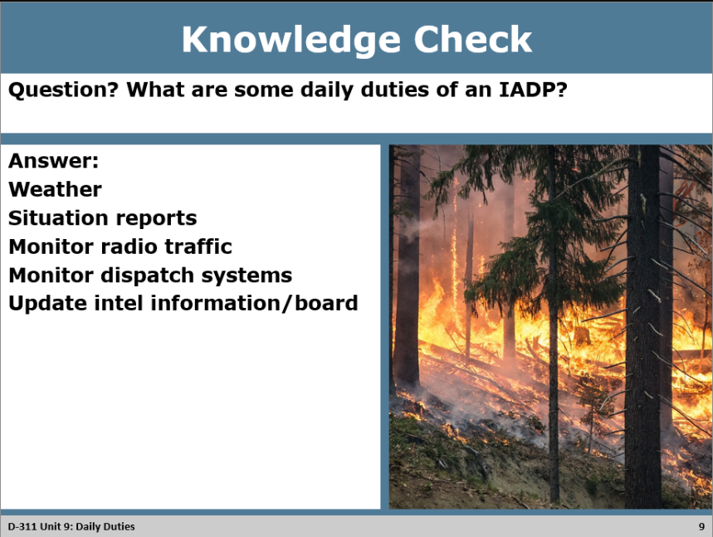
Knowledge Check Discussion
DO: The purpose of the knowledge check is to see if students remember some daily duties of the IADP.
- Review the Knowledge Check Question with the participants.

- Call on a participant(s) to provide an answer to the question.

- Display the answers on the PowerPoint slide.

ASK: <Ask to see what questions the participants may have about the question and answers provided.>
Answer: Respond to questions as needed.

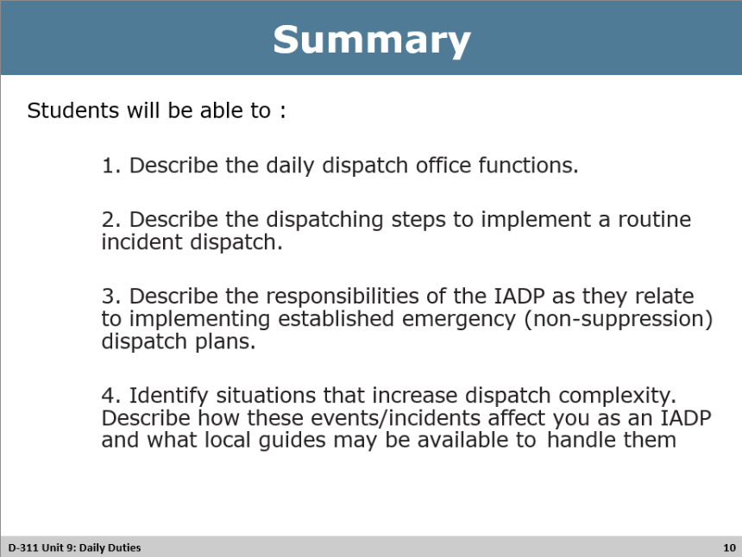
Summary
DO:
- Refer to the PowerPoint Summary slide.
- Review with participants the learning outcomes of the unit.

